Subreddit: wallstreetbets, it was the top 1 at 24/4/2022

Data collected at 4/5/2022

red top 1 post of that month

https://www.reddit.com/r/wallstreetbets/comments/txma40/wallstreetbets_predictions_tournament_for_april/?utm_source=share&utm_medium=web2x&context=3

blue top 2 post of that month

https://www.reddit.com/r/wallstreetbets/comments/ufc3eu/alright_boys_time_for_some_classic_wsb_degeneracy/?utm_source=share&utm_medium=web2x&context=3

green top 3 post of that month

https://www.reddit.com/r/wallstreetbets/comments/twk0qn/our_savior/?utm_source=share&utm_medium=web2x&context=3

yellow top 4 post of that month

https://www.reddit.com/r/wallstreetbets/comments/u7wtfh/5k_to_100k_overnight_nflx_put/?utm_source=share&utm_medium=web2x&context=3

pink top 5 post of that month

<https://www.reddit.com/r/wallstreetbets/comments/ug4351/suffering/?utm_source=share&utm_medium=web2x&context=3>

Whole graph

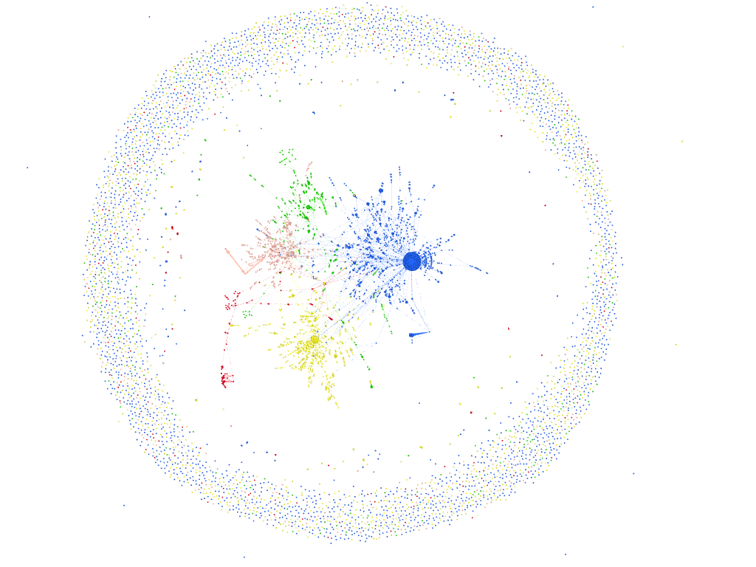

Some important people:

Red arrows: the comments that user did.

Blue arrows: the comments he got

Some big arrows represent big weights. Weight = how many times someone commented in the same person

Some other graph photos



